A000-Indo-Papua New Guinea-Trobriand Islands-Kula Trade Canoe Prow-20th c

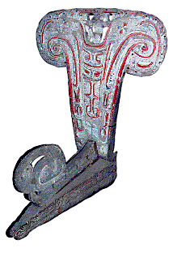

**Model Prow of a Kula trade canoe,** Papua New Guinea, Trobriand Islands, Kailuena Island, Kaduwaga Village.

**Case no.: Oceania**

**Accession Number:**

**Formal Label: Model Prow of a Kula trade canoe,** Papua New Guinea, Trobriand Islands, Kailuena Island, Kaduwaga Village.

**Display Description: Prows, such as this model Trobriand outrigger prow are complex and contain many different motifs.** One of the early classics of Western anthropology is Bronislaw Malinowski's ***Argonauts of the Western Pacific*** in which he studied the long Trobriand Kula trade voyages in their ocean-going outrigger canoes and the complex circular exchange route of gifts between the trading partners.

**LC Classification:** GN671.N5

**Date or Time Horizon:** mid-20th century

**Geographical Area:** Papua New Guinea, Trobriand Islands, Kailuena Island, Kaduwaga Village.

**Map, GPS coordinates: Latitude**. -8.5000°, **Longitude**. 150.9333°

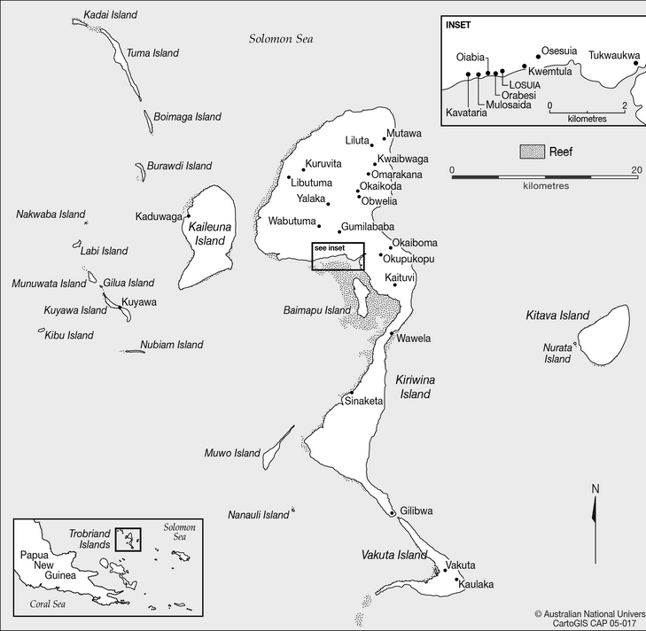

Map of the Trobriand Islands, showing their placement with regard to Papua New Guinea, by the Australian National University. From https://upload.wikimedia.org/wikipedia/commons/6/60/05-017_Trobriand_Is.png

**Cultural Affiliation:** Northern Massim.

**Medium:** wood

**Dimensions:**

**Weight:**

**Condition: original**

**Provenance:** Trobriand Islands, Kailuena Island, Kaduwaga Village.

**Discussion:**  
The Trobriand Islands, a group of about 20 islands and islets are founded on coral formations and are fringed by coral reefs. The nine populated islands, Kitava, Kiriwina, Vakuta, Kaile’una, Muwa, Kuiawa, Munuwata, Tuma, and Simsim, are considered an important tropical rainforest eco-region.

The Trobriand Islanders became famous because of Bronislaw Kaspar Malinowski who did field research on the islands between 1916 and 1920 and published his results as *Argonauts of the western Pacific* in 1922 (see Young, 2004; also Senft, 1999).

Linguistically, the Trobriand Islanders speak Kilivila, a Western Melanesian Oceanic language belonging to the ‘Papuan-Tip-Cluster’ group (Ross, 1988, p. 25, pp. 190ff; Senft, 1986, p. 6). On Kaile’una this language has many terms for different types of soils, plants and gardens that reflect the importance of gardening, in which the women do slash and burn cultivation of the bush to produce their most important crop, yam. Kilivila also has nautical terms for canoes and canoe parts, ocean terms such as currents, reefs and corals, and different types of sea creatures because the men are famous for being excellent canoe builders, carvers, and navigators in connection with the ritualized Kula trade. (Senft 2008) The Kula trade involves an exchange of valuable shells (which are considered a type of currency). It involves voyages in ocean-going outrigger canoes and a complex circular exchange route of gifts between the trading partners. This trade encompasses a wide area of the Melanesian Pacific (see Malinowski, 1922). So the society has a nice gender balance of women doing the gardening and men involved in the Kula trade and in furtherance of this balance they are both matrilinear and virilocal.

References

Malinowski, B., 1922. *Argonauts of the western Pacific: an account of native enterprise and adventure in the archipelagoes of Melanesian New Guinea with a preface by Sir James George Frazer.* Studies in economics and political science; no.65. London: Routledge and K. Paul, Ltd; New York: E.P. Dutton and Co.

Malinowski, B. 1935. *Coral Gardens and Their Magic*. Vol. I: *The Description of Gardening.* Vol. II: *The Language of Magic and Gardening*. London: George Allen and Unwin.

Ross, M.D. 1988. *Proto Oceanic and the Austronesian Languages of Western Melanesia.* Canberra: Pacific Linguistics.

Senft, G. 1986. *Kilivila – The Language of the Trobriand Islanders*. Berlin: Mouton de Gruyter.

Senft, G. 1999. “Bronislaw Kasper Malinowski.” In: Verschueren, J., Östman, J.-O., Blommaert, J. (Eds.), *Handbook of Pragmatics. Supplement 1998*. Amsterdam: John Benjamins, pp. 1–10.

Senft, G. 2008. “Landscape terms and place names in the Trobriand Islands – the Kaile’una subset,” *Language Sciences* 30: 340–361.

Young, M. 2004. *Malinowski: Odyssey of an Anthropologist 1884–1920.* New Haven and London: Yale University Press.